5 * Architecture and High-Level Design >2000 words
The architecture provides the top-level design view of a system and
provides a basis for more detailed design work. These are the top level components of the system you are building and their relationships.

5.1* System Architecture and Design
This section provides a high-level overview of the structural and functional decomposition of the system.
Focus on how and why the system is decomposed in a particular way rather than on details of the particular components.
Include information on the major responsibilities and roles the system (or portions thereof) must play.
A block diagram representation of the architecture must be included, which should show the hierarchical structure of the modules; interaction and interface among modules and with databases, external software, system, and networks
Provide a description and block diagrams of a system element or set of elements at a conceptual or functional level that describes a clearly defined view or model of the entire system or a subset of the system. Each component represents a similar grouping of functionality.
State clearly who is responsible for which module/task

5.2 * Hardware Architecture
Show hardware block diagram showing hardware functional blocks and how they interface.
State clearly who is responsible for which module/task

5.3 * Software Architecture (only required if your design includes software)
Show software block diagram
State clearly who is responsible for which module/task

5.4 * Rationale and Alternatives
This section discusses why you are using the architecture or approach you have decided upon.
A discussion of other architectures or approaches considered should be presented here.

General Principles: What comes under “Architecture and High-Level Design”

1. System Overview
- A brief description of the overall system or solution.
- Summary of key functions or goals (e.g., signal processing, control, communication, automation).
- Block diagram of the system.

2. System Architecture
- Top-level architecture showing major subsystems or modules.
- Indicate how hardware and software components interact.
- Mention power sources, communication buses, microcontrollers, etc.

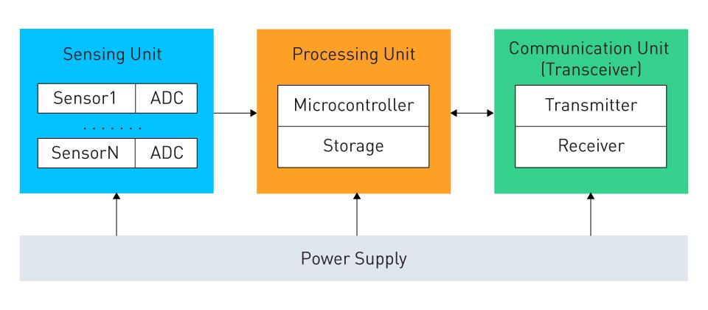

3. Functional Blocks
- Break down each block in the architecture diagram:
  - What each block does (e.g., sensor interface, signal conditioning, ADC, controller, display).
  - Inputs and outputs.
  - Interfacing standards (e.g., I2C, UART, SPI, analog, digital).

4. Design Choices and Trade-offs
- Justify key architectural decisions.
- Discuss alternatives that were considered and why they were rejected.
- Mention constraints (cost, power, space, processing speed, etc.).

5. Communication and Control Flow
- Describe how data or signals flow through the system.
- Explain control hierarchy (e.g., which component is the "master").
- Flow diagrams or finite state machines (FSMs), if applicable.

6. High-Level Software Architecture (if applicable)
- Description of software layers or modules (e.g., firmware, drivers, application logic).
- Interfaces between software modules and hardware.

7. Tools and Platforms
- Mention hardware platforms (e.g., Arduino, STM32, Raspberry Pi, custom PCB).
- Software environments (e.g., MATLAB, Simulink, KiCad, LTspice, Python, etc.).

Optional: Security and Safety Considerations
- Any measures considered for fail-safe operation or protection (especially in critical systems).

Example:
